

***A Project Design Report***

***On***

## Indian Sign Language Recognition

***Submitted by:***

### Team Infinity (AICB1 – AI06)

|  |  |
| --- | --- |
| 01 | **Hari Lakshmi A. S** |
| 02 | **Anushka Bajirao Patil** |
| 03 | **Mekapothu Manikanta Reddy** |
| 04 | **Pavaneswar Akula** |
| 05 | **Vrushali Arun Ghuge** |
| 06 | **Sikandar Baksh** |

*Under the guidance of*

### Ms. Diana Baby

Project guide cum Mentor



# INTRODUCTION:

Around 466 million people worldwide have hearing loss, and 34 million are children. `Deaf' people have very little or no hearing ability. They use sign language for communication. People use different sign languages in different parts of the world. Compared to spoken languages they are very less in number. India has developed a sign language by the name Indian Sign Language (ISL). In developing countries, there are only countable schools for deaf students. The Unemployment rate among adults with hearing loss is very high in developing countries .Our project aims to reduce the basic step in bridging the communication gap between normal people and deaf people using Indian sign language. Effective extension of this project to words and common expressions may not only make deaf people communicate faster and easier with the outer world, but also provide a boost in Developing autonomous systems for understanding and aiding them

# WEB DEVELOPMENT TOOL:

In our project we choose Gradio as our web development tool. Gradio is graphical interfaces for Machine Learning models.

Creating Machine Learning models is nowadays becoming increasingly easy thanks to many open-source and proprietary based services (e.g. Python, R, SAS). Although, practitioners might always find it difficult to efficiently create interfaces to test and share their completed model to colleagues or stake holders .One possible solution to this problem is Gradio, a free open-source Python package which helps you to create models. Gradio is perfectly compatible with many Machine Learning frameworks (e.g. TensorFlow, PyTorch, etc…) and can be used even for arbitrary general-purpose Python scripts.

The Gradio library is efficient and it helps solve a huge problem plaguing the Machine Learning community – model deployment .According to study, 90% of Machine Learning models built are not deployed, and Gradio will be the efficient method to fix that .It also serves as a way for beginners and experts to show off their models and also test the models in real life.

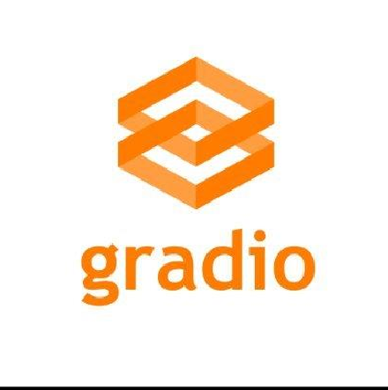

# SOFTWARE:

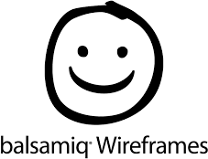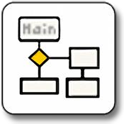

**WIREFRAME:**

Wire framing is a way to design a website service at the structural level. A wireframe is commonly used to layout content and functionality on a page which takes into account user needs and user journeys. Wireframes are used early in the development process to establish the basic structure of a page before visual design and content is added.

## ADVANTAGES OF WIREFRAME:

* One of the great advantages of wireframing is that it provides an early visual that can be used to review with the client
* Wireframes helps designers layout many sections of the website, resulting in a more fluid creative process.
* Wireframes can also help deliver the core message of your website more effectively and gather feedback at an early stage.

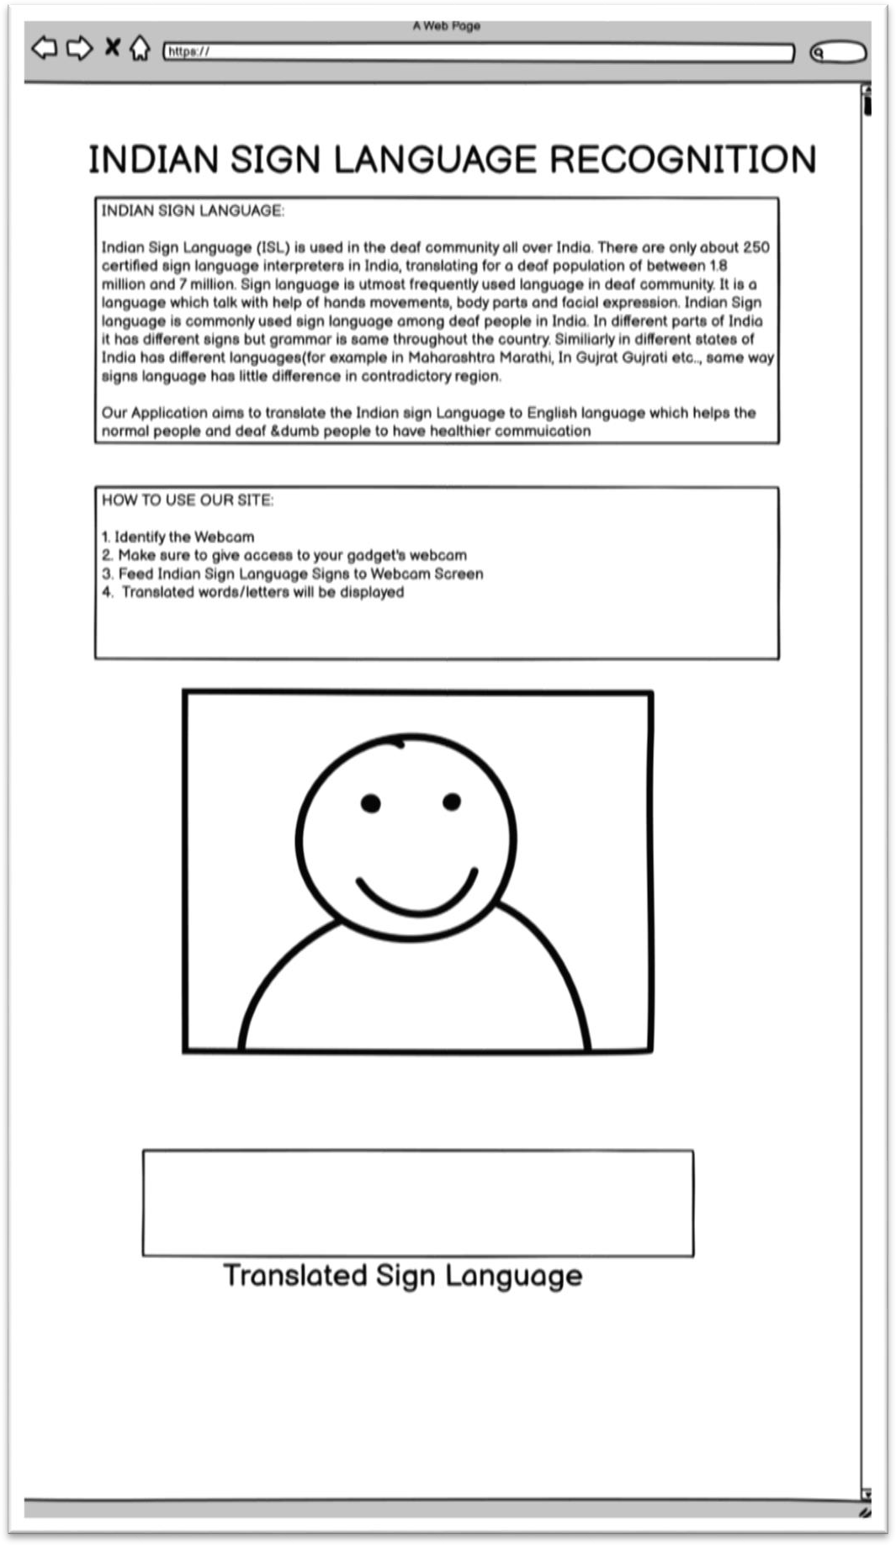

# USERFLOW:

A user flow is a chart or diagram showing the path a user will take in an application to complete a task. Product teams build user flows to intuitive design products, present the correct information to users at the right time, and allow users to complete desired tasks in as few steps as possible.

## ADVANTAGES OF USERFLOW:

* Product managers, UX designers, and other product team members employ user flows.
* They communicate product goals and plans to stakeholders.
* They speed development and reduce errors

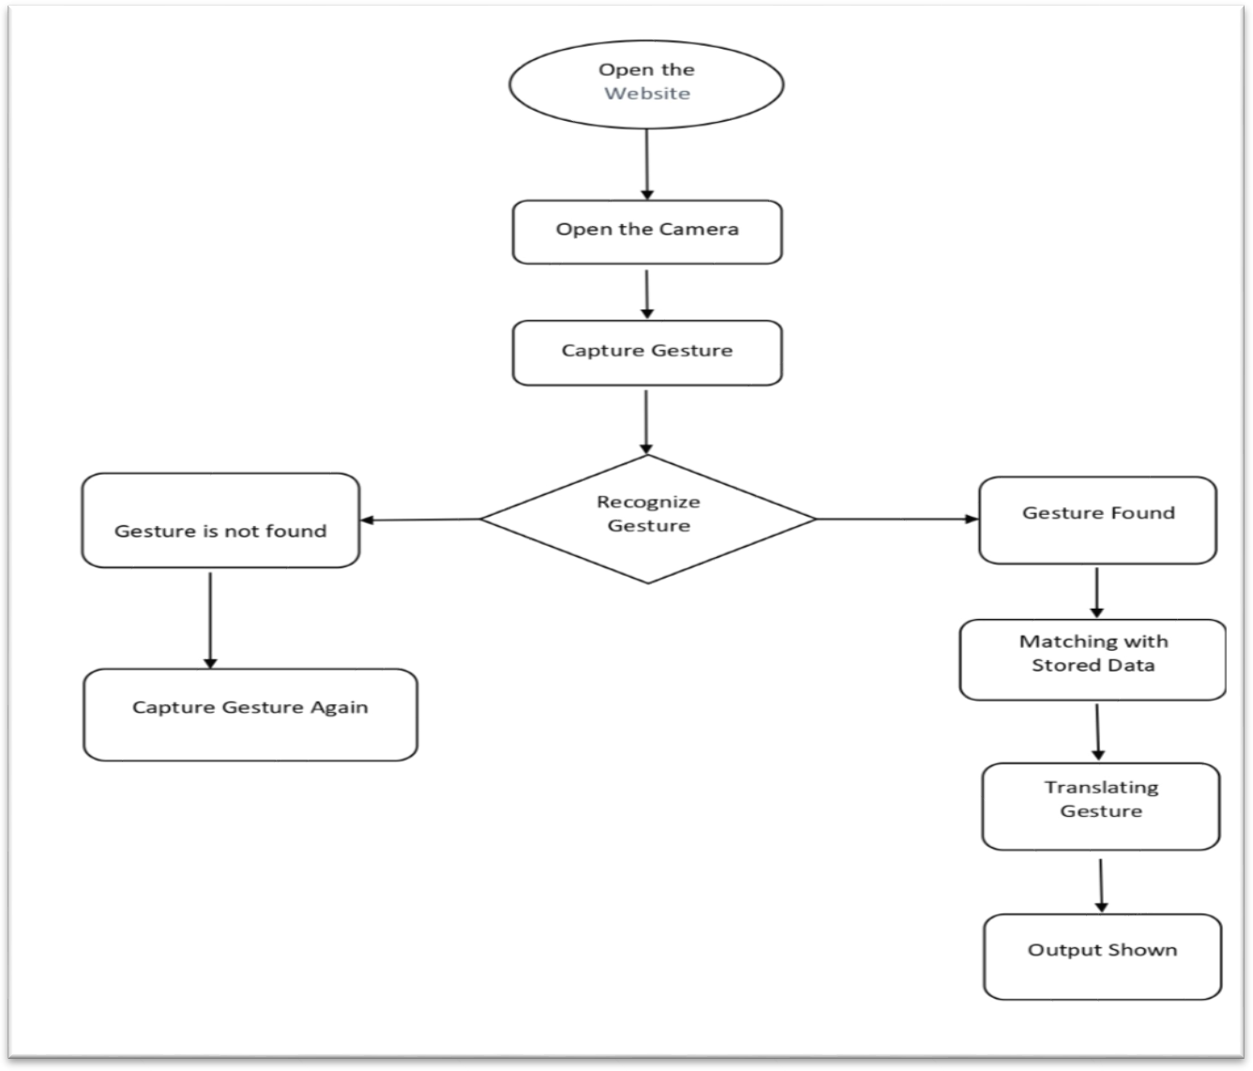

# SITEMAP:

A sitemap is a blueprint of your website that help search engines find, crawl and

index all of your website’s content. Sitemaps also tell search engines which pages on your site are most important. Sitemaps may be addressed to users or to software. Many sites have user-visible sitemaps which present a systematic view, typically hierarchical, of the site. These are intended to help visitors find specific pages, and can also be used by crawlers. Alphabetically organized sitemaps, sometimes called site indexes, are a different approach.

